Thread Creation in Java
There are 3 important ways to create/execute tasks using threads in Java:
- Extending Thread Class
- Implementing Runnable Interface
- Using Callable

Extending Thread
Thread is a Java class that represents an actual thread of execution.
It provides the mechanism to create, start, and control a thread.

- Created Thread1 Class by Extending Thread Class
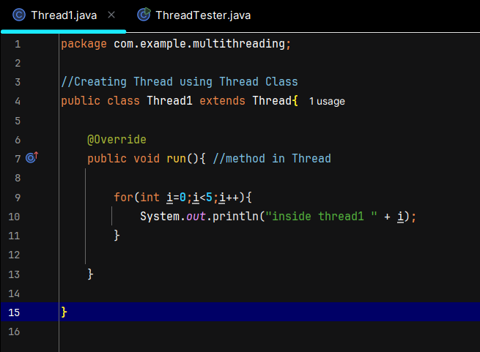

- Using ThreadTested Class to Run the User T1 without setting it to Daemon
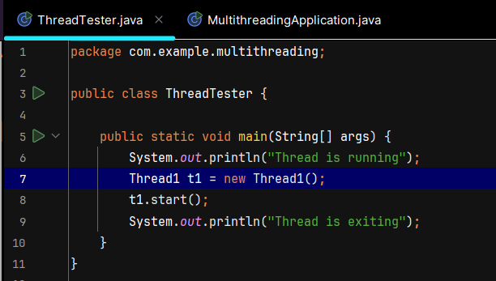
- Output if I run this -
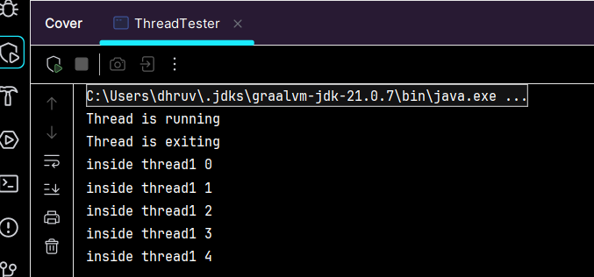
- Using ThreadTested Class to Run the User T1 setting it to Daemon
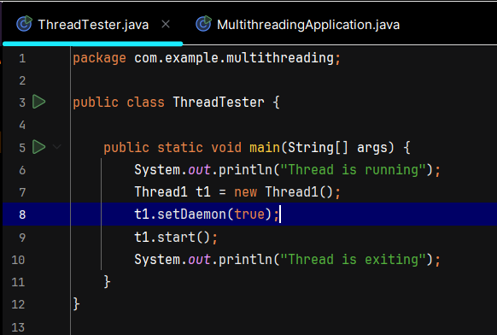
- Output if I run this - bcz now t1 is daemon thread and JVM will not wait for it to finish - JVM will terminate the program once the user thread is completed
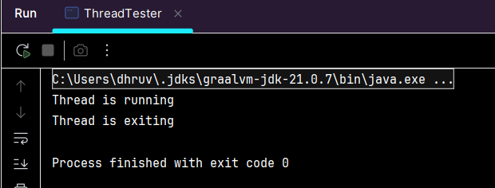
and we should not make any assumption about the order in which it will show output , its platform dependent and decided by the JVM
And We can also Name our Thread - by this in build method - and using Constructor

we can pass the name , while creating the new Thread and to set it we need to write down the constructor
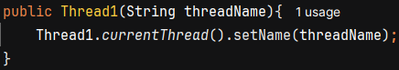
Constructor to set name to the thread
to get the name of the current Thread

What does Thread actually provide?
The Thread class provides things related to the thread itself, such as:
t.start(); // Start the thread
t.sleep(1000); // Pause execution
t.join(); // Wait for thread to finish
t.interrupt(); // Interrupt the thread
t.isAlive(); // Check whether thread is alive
t.setName(...); // Set thread name
t.setDaemon(...);// Make it daemon
So conceptually:
Thread represents the worker/execution mechanism

Implementing Runnable Interface
Runnable is a functional interface in Java that represents a task that can be executed by a thread.
Then why do we need Runnable?
This is where the distinction matters.
Runnable represents the task, while Thread represents the thread that executes the task.
Runnable
↓
"What should be done?"

Thread
↓
"Which thread will execute it?"

- Created Thread2 by Implementing Runnable Interface
- in Runnable Interface - run method is abstract , so we have to give the implementation of it
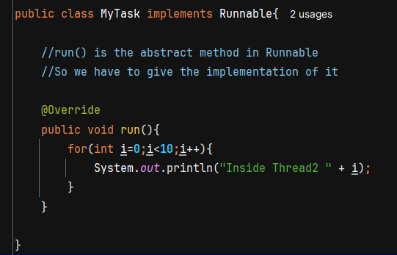
- we can run it or execute it like this
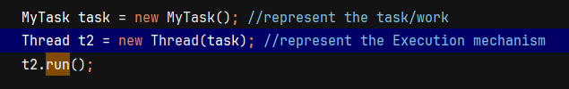
WHY Runnable IS PREFERRED?

Runnable separates the TASK from the THREAD.

Task:
"What should be executed?"

Thread:
"Which thread will execute it?"

Advantages:
- Java supports single inheritance, so extending Thread uses the only available parent class.
- A class can extend another class and still implement Runnable.
- The same Runnable task can be given to different threads.
- Works naturally with ExecutorService and Thread Pools.
- Better separation of responsibility.
IMPORTANT:

For learning:
extends Thread → understand how threads work
implements Runnable → understand task vs thread

In real production:
Runnable / Callable + ExecutorService / Thread Pool
CompletableFuture for asynchronous operations

Extending Thread is generally not preferred for normal application development.

